REPORT ASSIGNMENT

Name: Nguyễn Đức Huy

Class: CC01

1. ***Beginning***

In the beginning of the game, we will print the rule of the game for two players to read. If the players understand the rule, press any key to continue. 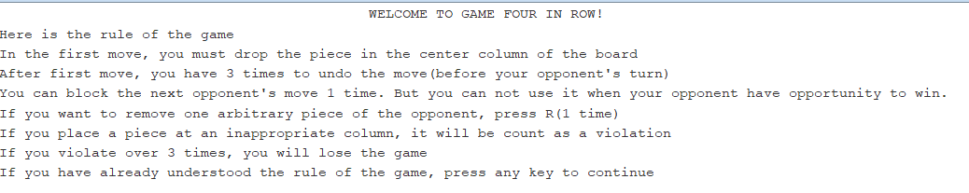

After reading the rule, game will require two players to enter their names.

We store name of each player to $s1 and $s2 so we can use it later.



After entering their name, game will assign piece randomly for each player.

We use syscall 42 to random choose between 0 and 1.

If the result is 0, we will assign the player 1 X and the player 2 O.

Else if the result is 1, we will assign the player 1 O and the player 2 X.



1. ***Game***

In each move, the console will print the number of remaining undo, violation and the name of the player.

We use list violation and list undo to store the number of violation and undo times of each player.

For example, in the beginning:

List violation = (3, 3) (each player has 3 times remaining to violate)

We store an array with 42 ‘*’ to print the board.

First, we will output array[0] -> array[6]. Then create a new line.

Then continue output array[7] -> array[13]. Then create a new line.

The same until array[41].

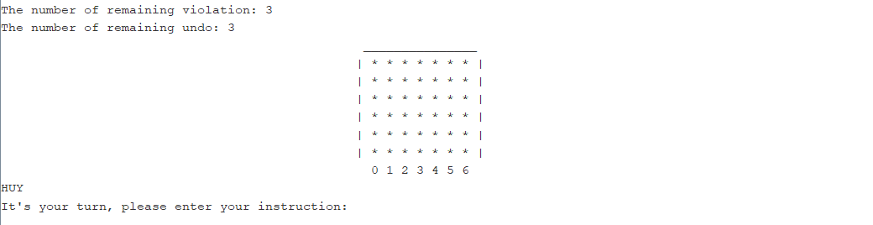

In the first move, player must place the piece in the center of the column of the board. If you enter other instructions, you will be required to enter the instruction again.

We will load the char you input and compare it will ‘3’. If it’s different, we will require you to input again.

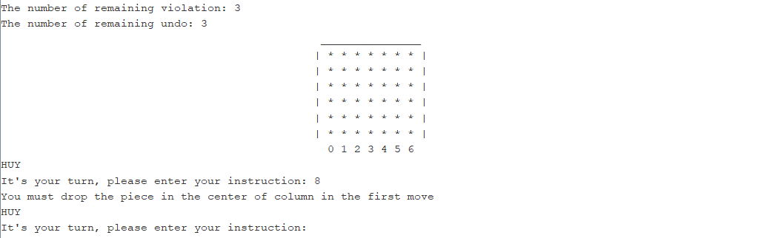

Enter the instruction again

Not middle column

After first move, the player can enter instruction with 0, 1, 2, 3, 4, 5, 6, R.

0->6 is the column that player wants to place the piece while R is the remove instruction.

If you enter other instructions, it will be count as violation and game will require you to enter the instruction again.

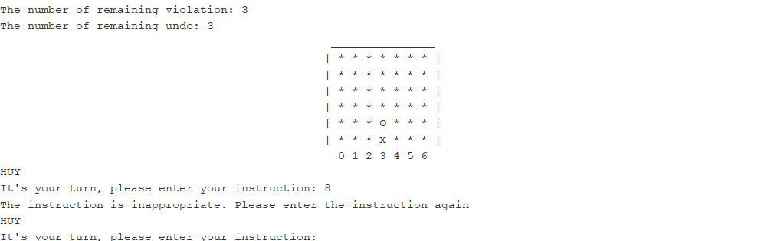

Enter the instruction again

Inappropriate column

**Enter column:**

When you enter appropriate column, for example you input 4.

We will assign j = 4. And we will check from t = 35 + j.

If array[t] == ‘*’ we will assign piece of this player to this position.

Else reduce t = t – 7 until find black position or t < 0.

If t < 0, your instruction will be count as violation.

**Undo:**

When we find the blank position and assign piece. We will also use a variable to store this position so when you want to undo, we just assign ‘*’ to this position.

If you enter appropriate instruction, the console will print the board again and ask you want to undo the last instruction or not. If yes, press Y. If no, press any other keys to continue.

If you run out of undo times and you still press Y, it will be count as a violation.

Case when you press Y when you still have undo times:

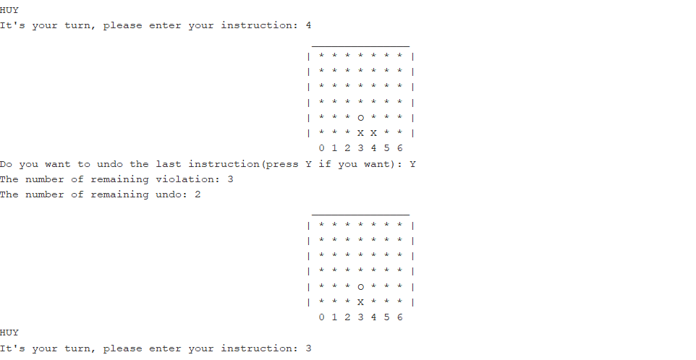

Then you can enter again the instruction

Press Y, it will undo the last instruction

The new piece is inserted

**Block:**

The idea I used in block is to assign each blank piece(‘*’) with opponent’s piece. After that, use function to check victory. But carefully that it must have the piece below that piece so it must be count as an opportunity to win. For example:

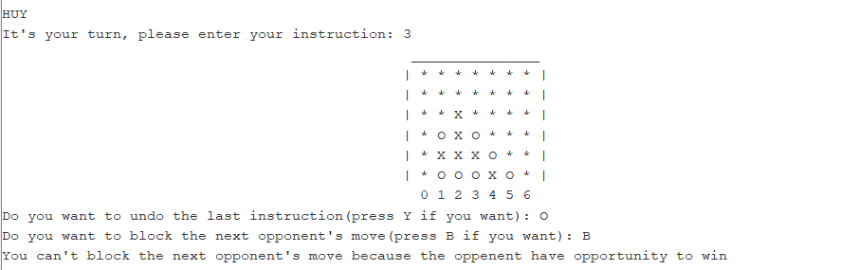

It’s an opportunity to win

It has a piece below

Assign X into this piece and check victory

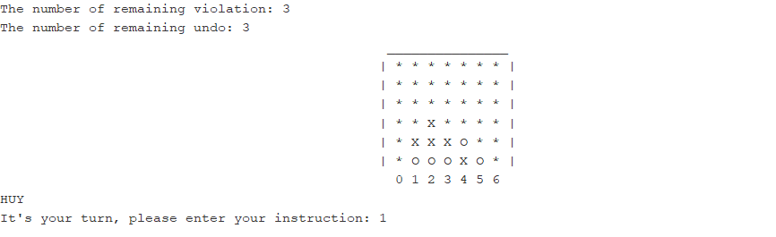

It’s not an opportunity to win so you can block

The piece below is blank

Assign X into this piece and check victory

If you don’t undo the last instruction, the player will be asked to want block the next opponent’s move or not. If yes, press B. If no, press any other keys to continue.

If you run out of block times and you still press B, it will be count as a violation.

Case when you press B when you still have block times:

The opponent will be blocked and you will be continued to play.

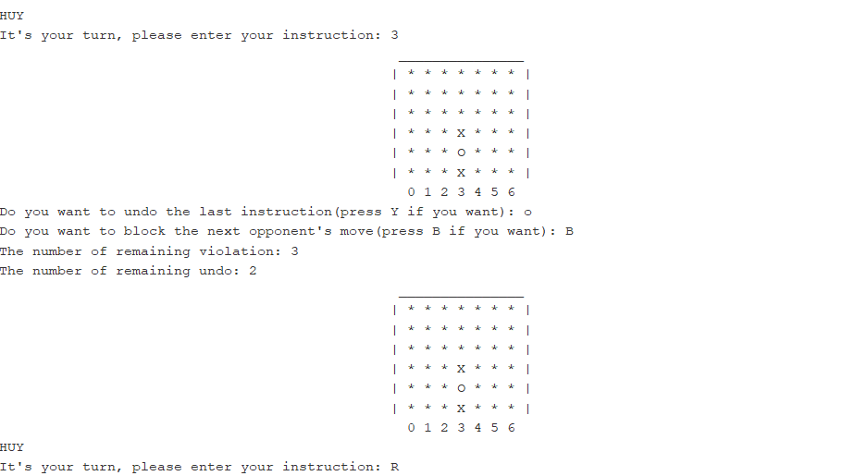

It’s still your turn

Press B to block next opponent’s move

**Enter remove:**

When you want to remove, we will ask you enter the row and the column of piece you want to remove. Let’s assign i is the row of the piece you want to remove and j is the column of the piece you want to remove.

I can get the position of the piece in the array with formula 7*i + j.

We will continue to check if this position is opponent’s piece or not.

If it is, you can remove the piece.

Else, it will be count as a violation and you need to enter the row and the column of the piece you want to remove again.

About drop down the pieces above, with t = 7*i+j.

Assign array[t] = array[t-7] then t = t – 7.

Continue like above until t < 0.

If you enter R instruction, you will be asked about the row and column of the piece you want to remove.

If you enter the appropriate piece, the piece will be removed and any pieces above this piece will fall down.

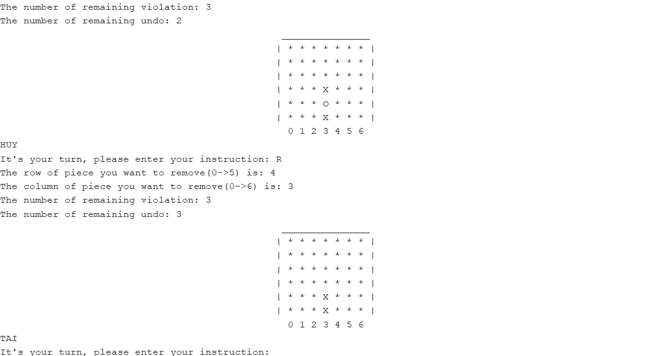

After removing, the pieces above will drop down

The piece you want to remove is placed at (4,3)

If you enter inappropriate piece( ‘*’ or your piece), it will be count as a violation. You will be required to enter again .

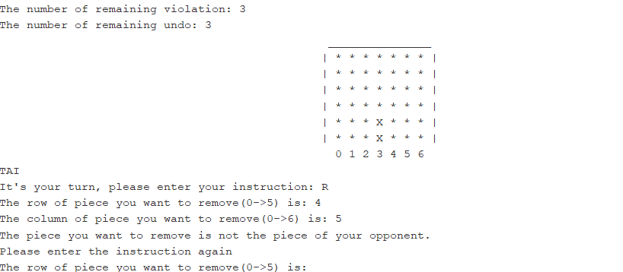

Enter again

Inappropriate piece

The piece you want to remove is placed at (4,5)

1. ***End***

When you win, the console will print your name, number of pieces you used and the piece you used.

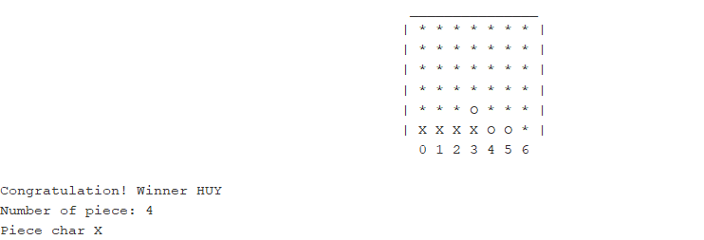

When we check the win with row.

Firstly, I divide checking with each row.

With row 0, variable count to count the number of consecutive similar pieces.

If piece is different from black piece, count = 1.

Else if piece is blank, count = 0.

Else if piece is different from previous piece and not black piece, count = 1.

Else if it’ s the same as previous piece, count++.

When count == 4, jump out and print win game.

Continue with other rows like row 0.

The idea was the same for column. Just different from the way to access the piece with the same column, use +7

The idea was also the same for diagonal. But to create the begin and the end of the diagonal to check.

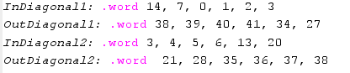

With diagonal from left to right, use +8 to access the next piece on the same diagonal.

With diagonal from right to left, use +6 to access the next piece on the same the diagonal.

When tie game, the console only print the board.

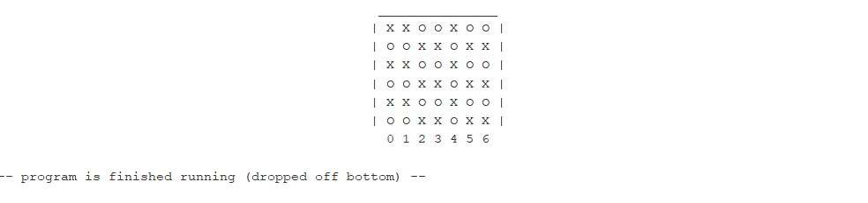

To check tie, we easily check the number of row 0 ( from array[0] -> array[6]).

If the number of pieces is 7, it’s tie game.